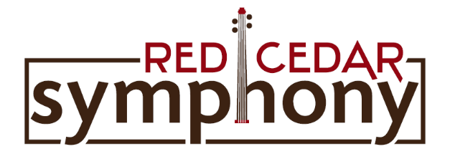
PMB 109 - 330 S. Main Street - Rice Lake, WI 54868
RedCedarSymphony.org

Application for
The Red Cedar Symphony Orchestra Concerto Competition- 2020

The Red Cedar Symphony Orchestra will host a concerto competition to select a maximum of two artists to perform as soloists with the Red Cedar Symphony. The orchestra invites those to compete who are from northwestern Wisconsin. Strings, classical voice, piano, wind, percussion, or brass instruments may compete by age category. The winner(s) will perform with the Red Cedar Symphony at its concert to be held Saturday, March 28, 2018 at Chetek Lutheran Church in Chetek, WI at 7:00 pm and Sunday, March 29, 2018 at Bethany Lutheran Church in Rice Lake, WI at 4:00 pm.

Criteria

1. The competition is open to musicians of high school age and older.

2. Musical selections must be standard repertoire and have available orchestra parts. Vocalists must select an aria (with preceding recitative, if available and appropriate) from a major oratorio or opera. All selections must be between four and fifteen minutes in length.

3. Memorization is optional, but preferred.

4. The application deadline is December 15, 2019. Please include a $10.00 application fee. Checks may be made payable to the Red Cedar Symphony.

5. Auditions will be held Saturday, January 18, 2020, at Bethany Lutheran Church in Rice Lake, WI. Each performer must provide a piano accompanist for the audition. (An accompanist for the piano category is optional, but preferred.) All contestants will be notified of their audition time by telephone or email. Winners of the concerto competition will be announced and posted one hour following the auditions and notified by telephone or email.

Disclaimer: The judges reserve the right not to select a winner.

Mail the completed application form and $10 fee to:

Red Cedar Symphony
PMB 109
330 S. Main Street
Rice Lake, WI 54868
For assistance with your application, please contact Robin Fossum at 715-642-2414 or e-mail at rkfossum@gmail.com.

